**Cover Letter of Transmittal**

UNCC FFGRAT Team

9201 University City Blvd.

Charlotte, NC 28223

December 6, 2015

Senior Design Committee,

This document contains a general overview of the progress made by the UNCC_FFGRAT Senior Design Team during the Fall 2015 semester. The project is a culmination of research conducted by the Precision Optical Fabrication Research Group at UNCC under Dr. Matt Davies. The goal of this project is to design and test a device capable of producing micro-patterns on an optic of arbitrary shape through the use of a diamond-tip tool or a stylus. The device is required to make gratings on a copper tests flat; however, the design goal is to create these patterns on free form optics.

The proposed design is a double flexure based system modeled after an atomic force microscope (AFM). In this design, the tool tip will act like the probe of the AFM; transferring the force at the tool/part interface. The capacitance gage will measure the tool tip displacement by detecting the displacement of the inner flexure. A force will be applied to the outer flexure by the voice coil to move the entire apparatus in order to keep the force at the tool tip constant.

Research began with a detailed literature review pertaining to the main areas of study for this project. Multiple design concepts were analyzed and presented to several members of the UNCC staff. The final design mentioned above was chosen for further research and prototyping. To date, several iterations of the prototype have been considered and reviewed by industry experts in order to optimize the design. The current design has been modeled and analyzed in SolidWorks, ABAQUS, and MathCAD. An accurate model for the control system has been designed, but further consultation and research is required for completion. Several design considerations have been made to account for mechanical failure (yield, fatigue) as well as system failure (integral windup, operator error).

Future plans include implementing feedback from the Senior Design Expo, finalizing the electrical schematics for the design, and building a prototype. The prototype will be tested and “tuned” for optimal performance. Once a working model has been achieved, all findings will be documented and presented to the UNCC Senior Design Committee.

Sincerely,

Alex Blum, Spencer Greer, and Preston Hamby

A directory containing all pertinent documents was placed on two DVD’s and attached as a zip file. One copy of the DVD was given to Dr. Matt Davies (mentor), and the other to the senior design review committee. The folder name given to that file was UNCC_FFGRAT_Comprehensive_Submission. The files contained in this folder can be found in the table below.

Table of Contents

1. Cover Letter of Transmittal 2
2. Overview of Document 3
3. Project Description/ Statement of Work 3
   1. General Requirements 3
   2. Performance Specifications 3
   3. Project Specifications 3
4. Design Narrative 4
   1. Review of Design 4
   2. Literature Review 5
   3. Design Review 5
   4. Flexure Design 6
      1. Outer Flexure Design 6
      2. Inner Flexure Design 7
      3. Thermal Drift 8
   5. Control System Design 9
      1. Voice Coil 9
      2. Simulink Model 9
   6. Failure Mode and Effects Analysis 10
      1. Control Systems 10
      2. Flexure 10
5. Plans for Future 11
6. References 11
7. Appendices 12
   1. Flexure Design 12
      1. Design Specifications 12
      2. General Flexure Design 13
   2. Control Design 16
   3. Bill of Materials 17

# 1. Overview of Document

This document contains the design details for the work completed by the UNCC_FFGRAT Senior Design 1 Team along with future plans to be conducted next semester in Senior Design II. The purpose of this project is to design, test and implement a device for micro-patterning an optical surface of arbitrary (freeform) shape using a diamond tool or stylus. After several iterations and two design reviews a final design has been chosen by the team.

# 2. Project Description/Statement of Work

A device for micro-patterning optics of various shapes using a diamond-tip tool or a stylus will be designed and tested for this project. These micro-patterns will be used to enhance or change the optic’s overall function and capabilities. Initial testing will be conducted on copper test flats in order to analyze the efficacy of the design. If the device is functioning properly, the team will begin additional testing by producing gratings on free form optics. This device will be tested by the UNCC Center for Precision Metrology to validate project completion.

# 3. Project Specifications

The design testing and functionality of the prototype will be compared to the following performance specifications and design requirements.

## 3.1 General Requirements

Drawings adhering to the requirements of ISO-10110, Part 19 shall be provided for all fabricated parts.

## 3.2 Performance Specifications

PS1: Device must fit within a 150 mm cube.

PS2: Device must have a mass of less than 2 kg.

PS3: Device must be capable of being mounted on a Moore Nanotechnology 350 FG precision mill, as well as a Precitech Nanoform 350 precision lathe.

PS4: General motion requirements. The device will use the axes of the machine to which it is mounted to move in space over the surface of an optic and cut a pattern in the surface.  The pattern will be cut with a diamond point or other suitable tool. The project is currently targeting infrared (IR) applications, but may be extended into visible light imaging applications.

PS5: Depth control requirement.  The device must be capable of controlling the cutting depth by keeping either force or position constant while tracing a surface. This may be accomplished through the use of an active or passive system.

PS6: At a minimum device performance must be proven through the production of a linear grating pattern on a flat optical surface on a copper workpiece.  Ideally it will be capable of producing gratings in a range of materials, including copper, aluminum, brass, germanium, and chalcogenide glass.  Dimensional requirements are described in PS7.

PS7:  The grating must have a pitch that is less than or equal to 1 μm with a 1 μm depth of cut, for a one-to-one aspect ratio. This must be attained over a square workpiece with a total area of 100 mm2, or a circular workpiece with a diameter of 10 mm for the spiral grating. The uncertainty in mean grating pitch should be +/- 0.1 μm.  The above dimensions are suitable to produce optical function in IR optics operating in the wavelength range from 1-12 μm, but the creation of patterns that have an optical function for visible light are desired as well. The ideal result, while not required, is to produce patterns on the scale of the wavelength of visible light (400 nm- 700 nm).

PS8: Ideally, the device should also be able to produce gratings other than linear gratings such as, but not limited to, cross-patterns (pyramid structures), concentric circular gratings, and concentric square gratings.

PS9: The minimum linear velocity of the cutting tool is 20 mm/min.

# 4. Design Narrative

The following section will describe the design chosen by the team that is capable of meeting all of the design requirements listed above.

## 4.1 Review of Design

The overall design of the precision micro-patterning apparatus consists of three main components: the monolithic base-flexure, voice coil actuator, and the control system. The design of the system begins with the flexure. Proper flexure design governs the displacement range, resolution, natural frequency, and thermal time constant of the system. The flexure system was designed to provide a displacement range of ±20 μm, with a resolution of ±0.1 μm and a natural frequency of 200 Hz.

A monolithic base-flexure design was chosen to allow the voice coil to be mounted and coupled to the flexure with tighter tolerances, reducing assembly-related error. A push-rod with a flexible coupling will be used to transfer force from the voice coil into the system.

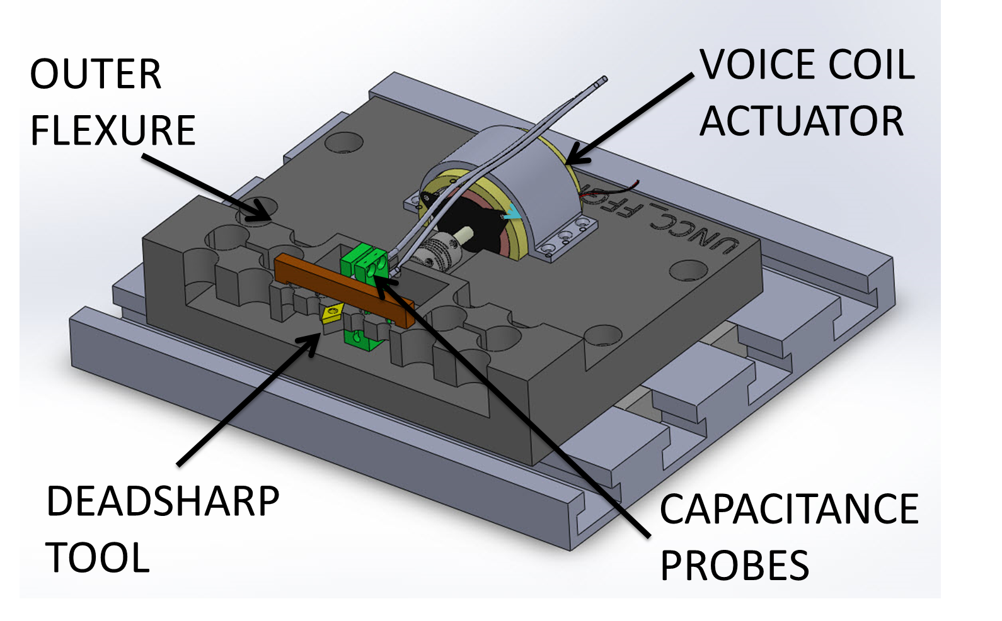

Figure 1 - Force Control Ruling Engine Design

## 4.2 Literature Review

To begin the design process, each member of the team constructed a literature review based on the following keywords: free form optical design, flexure design, slow tool servos, fast tool servos, diffraction grating, force control, and AFM design.  Once a knowledge base of information was established several conceptual designs were developed with significant input from Matt Davies and Stuart Smith.

## 4.3 Design Reviews

These conceptual designs were presented at the Conceptual Design Review (CDR) and input was received from Chris Evans and Matt Davies. The input from the CDR, along with new ideas discovered through further research were used to refine the conceptual designs. The surface-tracing flexure and control strategy eventually decided upon were both derived from techniques used in atomic force microscopy (Daniel Y. Abramovitch, 2007).

The final design was refined and presented to a panel of engineers including Dr. Chris Evans, Dr. Matt Davies, Dr. Steve Patterson, and Dr. Stuart Smith. This panel offered several additional design considerations along with feedback to be implement in the current design.

## 4.4 Flexure Design

The flexure design was conducted using Lagrange’s equation to determine the resolution, range, and natural frequency of the inner flexure, outer flexure, and combined assembly. Failure analysis of both the outer and inner flexures was conducted using a simplified cantilever beam model with notch concentration factors. Details of the analytical approach can be found in Appendix A.

### 4.4.1 Outer Flexure Design

Using this approach, the equivalent mass and equivalent stiffness of the outer flexure were found to be:

N·μm-1 (1)

gm (2)

These values were used to calculate the natural frequency of the outer flexure:

kHz (3)

As well as the tool tip displacement at 10 N of voice coil force:

μm (4)

This displacement value is supported by an ABAQUS convergence study, which found a displacement of 27.9 μm with the same amount of applied force. Both values are well over the minimum value of 20 μm.

Using a cantilever beam approximation, with the voice coil force divided evenly among all beams, the bending stress can be found by (Smith S. ):

MPa (5)

This gives a factor of safety of:

(6)

Fatigue analysis was also performed to determine the number of cycles the flexure can endure before failure. The endurance limit for 106 cycles was calculated using the equation (Juvinall):

(7)

This gives a fatigue factor of safety of:

(8)

Operating at the voice coil natural frequency, this gives a design life of about 70 hours.

### 4.4.2 Inner Flexure Design

The equivalent mass and equivalent stiffness of the inner flexure were found to be:

N·μm-1 (9)

gm (10)

These values were used to calculate the natural frequency of the inner flexure:

kHz (11)

As well as the tool tip displacement at 5 N of voice coil force:

nm (12)

Using a cantilever beam approximation, with the tool tip normal force divided evenly among both beams, the bending stress can be found by (Smith S. ):

MPa (13)

This gives a factor of safety of:

(14)

Fatigue analysis was also performed to determine the number of cycles the flexure can endure before failure. The endurance limit for 106 cycles was calculated using the equation (Juvinall):

MPa (15)

This gives a fatigue factor of safety of:

(16)

### 4.4.3 Thermal Drift

The change in material volume due to temperature variation can cause thermal drift, impacting measurement accuracy.. In order to account for thermal drift in this precision system, the heat generated by the voice coil must be taken into account. An analysis on thermal drift was performed with equations 17 and 18 for reliability of data. Equation 17 is used to find the volumetric thermal expansion coefficient, in this case of aluminum resulting in 69e^-6 m/mk.

(17)

Though the use of this value the volumetric expansion was able to be found in Equation 18. Equation 18 takes the thermal expansion coefficient into account to see the change in volume with respect to the change in temperature. At a change of plus or minus 0.1 degree Celsius the volume of the structure will change by 0.023mm

(18)

Additional analysis is necessary to determine the effect of heat generated by the voice coil.

## 4.5 Control System Design

### 4.5.1 Voice Coil

A voice coil from H2W Technologies (NCM02-17-035-2F) will be used for actuation in the system. The voice coil specifications were provided by the manufacturer and were used to determine the behavior of the system. The manufacturer’s inductance and resistance specifications were used to develop an estimate for the electrical time constant for the voice coil (Davies & Schmitz, 2015):

ms (19)

The manufacturer specifications for mass, resistance, back-emf constant, and motor torque constant for the voice coil were used to find the mechanical time constant (Davies & Schmitz, 2015):

ms (20)

This corresponds to a natural frequency of 200 Hz for the voice coil, which is the limiting frequency of the undamped system.

### 4.5.2 Simulink Model

The current Simulink block diagram of the control system is shown in Figure 2.

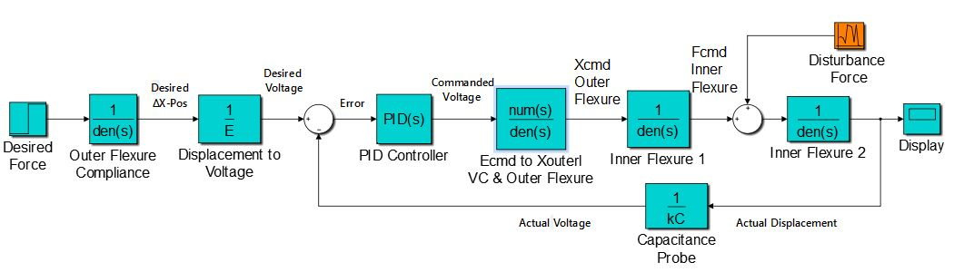

Figure 2 - Simulink Model for Current Design

## 4.6 Failure Modes & Effects Analysis

### 4.6.1 Control Systems FM & EA

**Integral Windup**

A PID control loop will be used to control the signal error. As with any PID controller, integral windup (or reset windup) will need to be accounted for. Integral windup will occur if the error signal reads large value for an extended period and the integral terms accumulate. Once the error signal returns to a “normal” value, the windup in the integral will cause the correction to “overshoot” and continue to be offset. This could cause the tool to crash into the part, or to miss the part entirely, for large sections of the run. This problem will be addressed by setting a “break” in the control loop. The loop will break if the measured value is over a certain value for a period of time.

### 4.6.2 Flexure FM & EA

**Fatigue Failure**

The prototype is made of Aluminum. As such, the S-n curve has no “knee”, the flexure will fail eventually under repeated loading. However, under the predicted loading the prototype will have a fatigue life of several hundred hours. Fatigue failure could damage the part and/or the tool, causing anywhere from a few hundred dollars (tool) to thousands of dollars (part) of damage. The most effective mitigation strategy for this failure mode is to not run the flexure past the intended design life. If successful, the prototype should be redesigned and manufactured from stainless steel to reduce the likelihood of this failure mode.

**Yield Failure**

Under normal operating conditions the flexure has a factor of safety of about 6. However, mishandling of the mechanism could cause the bending stress in a flexure notch to exceed the yield stress. This would not be likely to occur during a part run. Failure by this mode would most likely occur when mounting a tool to the flexure, or if sufficient care is not taken when handling the mechanism. Likelihood of this failure mode will be mitigated by designing a jig for safely mounting tools to the flexure, and by having written specifications for handling and transport of the mechanism.

# 5. Plans for Future

The following section will describe the future plans for this project. Senior Design will resume in the Spring 2016 semester.

* Control system Simulink model
* Electric schematic
* Thermal drift calculations
* Failure modes and effects analysis
  + Integral windup
  + Yield failure, fatigue failure
* Chip removal
* Testing and validation of inner and outer flexure designs
  + Machine prototypes
  + Validate calculations experimentally
* Shop drawings
* Complete testing of summer design
* Purchase requisitions
* Final design package
  + Expo poster
  + Comprehensive document submission

# 6. References

Daniel Y. Abramovitch, S. B. (2007). A Tutorial on the Mechanisms, Dynamics, and Control of Atomic Force Microscopes. *American Control Conference* (pp. 3488-3502). New York City: IEEE.

Davies, D. M. (2015, October 21). Professor. (P. H. Alex Blum, Interviewer)

Davies, M., & Schmitz, T. (2015). *System Dynamics for Mechanical Engineers.* New York: Springer.

Juvinall. (n.d.). *Fundamentals of Machine Component Design.*

Paros, J., & Weisbord, L. (1965). *How to Design Flexure Hinges.* Little Falls: Gyrodynamics Research.

Smith, D. S. (2015, October 22). Professor. (A. Blum, Interviewer)

Smith, S. (n.d.). *Flexures.*

Whitney, D. E. (1987). Historical Perspective and State of the Art in Robot Force Control. *International Journal of Robotics Research*, 3-14.

# 7. Appendices

## 7.1 Appendix A—Flexure Design

### 7.1.1 Design Specifications

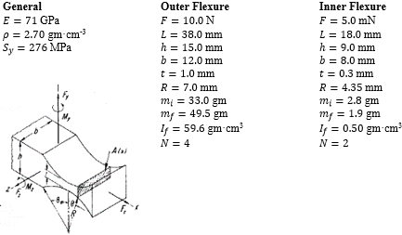

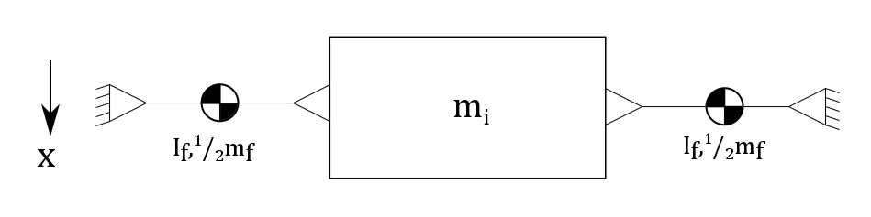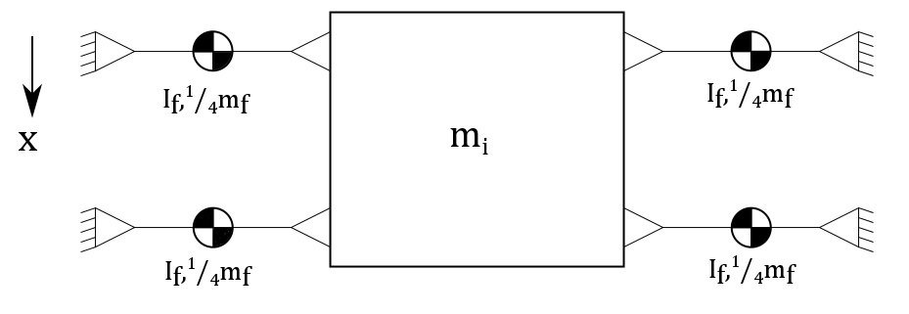

### 7.1.2 General Flexure Design

If the attenuation lever is ignored, using Lagrange’s equation to write the equation of the system:

(1A)

For this system, Equation 1A can be rewritten as:

(2A)

where:

is the kinetic energy, and

is the potential energy ,

The kinetic energy is given by:

(3A)

where:

is the inner mass,

is the inner mass linear velocity,

is the number of flexure arms,

is the flexure arm 2nd mass moment of inertia,

is the flexure arm angular velocity,

is the total flexure arm mass, and

is the flexure arm linear velocity.

The potential energy is given by:

(4A)

where:

is the potential energy,

is the flexure stiffness, and

is the flexure arm angular position.

If the inner mass is moved some distance x and the position, and therefore velocity, of any individual flexure arm can be related geometrically to this movement and the following substitutions can be made:

(5A)

If the small angle approximation is applied, these substitutions may also be made:

(6A)

The angular stiffness is given by:

(7A)

where:

is the elastic modulus of aluminum,

is the flexure width,

is the hinge thickness, and

is the hinge radius.

All hinges were designed as *right circular hinges*, so that the center of the radius lies on the edge of the hinge. This allows the angular stiffness to be obtained with Equation 7A (Paros & Weisbord, 1965). Substituting Equations 6A into Equation 4A yields:

(8A)

Comparing this equation to the general elastic potential energy equation shows that the equivalent stiffness of the flexure is:

(9A)

Applying the spring force equation with an input force shows that the flexure displacement is:

(10A)

Similarly, Equation 3A can be rewritten as:

(11A)

Comparing this equation to the general kinetic energy equation shows that the equivalent mass of the flexure is:

(12A)

Equations 9A and 12A can be used to find the natural frequency of the flexure:

(13A)

This analytical sequence was used to design both the outer and inner flexures.

For each flexure design the bending stress was expressed as:

(14A)

where:

is the flexure geometry factor,

is the moment applied,

is the flexure hinge thickness, and

is the flexure width.

The fatigue limit for each flexure was calculated as:

(15A)

where:

is the R.R. Moore endurance limit,

is the load factor,

is the gradient factor,

is the surface factor,

is the temperature factor, and

is the reliability factor.

## 7.2 Appendix B—Control Design

The electrical time constant for the voice coil is given by:

(16A)

where:

is the motor inductance, and

is motor resistance.

The mechanical time constant for the voice coil is given by:

(17A)

where:

is the motor resistance,

is the moving mass of the motor,

is the motor torque constant, and

is the back-emf constant.

Calculated and are consistent with those provided by the manufacturer.

## 7.3 Appendix C—Bill of Materials

|  |  |  |  |  |  |
| --- | --- | --- | --- | --- | --- |
| **Bill of Materials** | | | | | |
| **Item** | **Qty** | **Unit Price** | **Total** | **Vendor** | **Part/Model Number** |
| **Materials** |  |  |  |  |  |
| 6061-T6 Aluminum block 8"x8"x1.5" | 2 | $ 88.98 | $ 177.96 | OnlineMetals | <https://goo.gl/A2CYYj> |
| Moving Magnet Voice Coil Actuator | 1 | $ 752.00 | $ 752.00 | H2Wtech | NCM02-17-035-2F |
| Cap Gauge Probe | 1 | $ 665.00 | $ 665.00 | Lion Precision | C23-B/LEMO |
| Cap Gauge Amp/ Regulator | 1 | $ 8,170.00 |  | Lion Precision | CPL 190-3-3 |
| Optical Test Flat | 3 | $ 200.00 | $ 600.00 | UNCC MEES |  |
| **Tools** |  |  | $ - |  |  |
| 60 Degree Diamond Tipped Insert | 1 | $ 600.00 | $ 600.00 | K&Y Diamond | MN60ALGC-KD1550 |
| 45 Degree Diamond Tipped Insert | 1 | $ 600.00 | $ 600.00 | K&Y Diamond | MN45ALGC-KD1550 |
| 30 Degree Diamond Tipped Insert | 1 | $ 600.00 | $ 600.00 | K&Y Diamond | MN30ALGC-KD1550 |
| **Training** |  | **Hourly Cost** |  |  |  |
| HASS Training | 2 | $ 114.00 | $ 228.00 | UNCC MEES | N/A |
| SEM Training | 2 | $ 114.00 | $ 228.00 | UNCC MEES | N/A |
| **Labor** |  | **Hourly Cost** |  |  |  |
| Student Design Time | 80 | $ 100.00 | $ 8,000.00 | UNCC MEES | N/A |
| Mentor Consult Time | 0 | $ 150.00 | $ - | UNCC MEES | N/A |
| **Manufacturing** |  | **Hourly Cost** |  |  |  |
| Moore NanoTech Time | 30 | $ 75.00 | $ 2,250.00 | UNCC MEES | N/A |
| HASS Time | 80 | $ 75.00 | $ 6,000.00 | UNCC MEES | N/A |
| **Verification and Testing** |  | **Hourly Cost** |  |  |  |
| SEM Time | 2 | $ 114.00 | $ 228.00 | UNCC MEES | N/A |
|  |  |  |  |  |  |
| Total Cost (no donations) |  |  | **$20,928.96** |  |  |
| Total Cost (donations) |  |  | **$ 1,800.00** |  |  |